**Section 1: Connecting to an SDE database**

1. Open ArcMap C:\Program Files (x86)\ArcGIS\Desktop10.2\bin\Icons\ArcMap16.png or ArcCatalog C:\Program Files (x86)\ArcGIS\Desktop10.2\bin\Icons\ArcCatalog16.png
2. Under Catalog Tree, expand Database Connections:

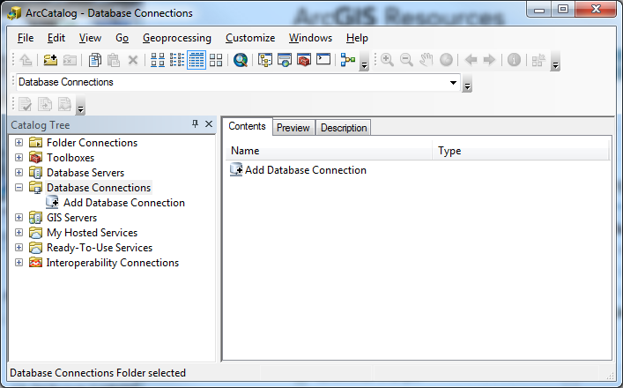

1. Double-click on **Add Database Connection**
2. Fill out Database Connection form:

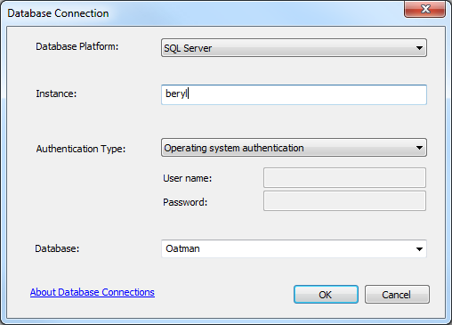

1. Click OK
2. Rename connection

**Section 2: Connecting to your version of the database**

1. Right-click database connection and select *Geodatabase Connection Properties…*

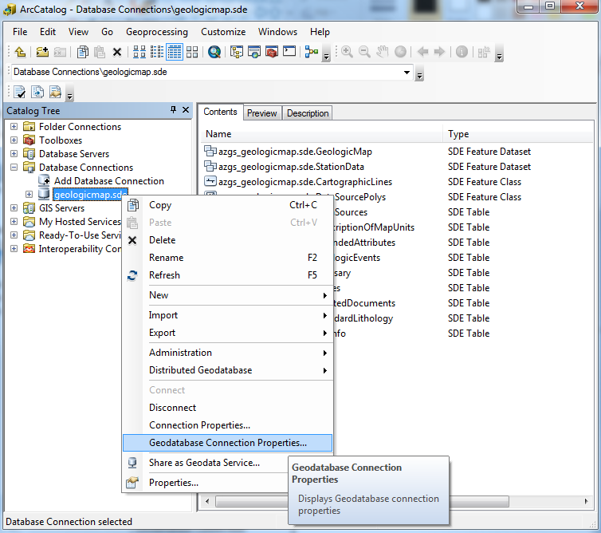

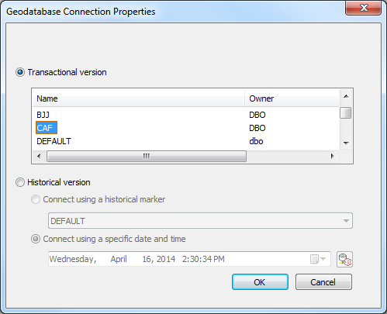

1. Select *Transactional version*
2. Click **OK**
3. You can rename (add “JES” for example) the connection file (“file”.sde is connection file, connects to multiple feature classes) to indicate the database and version.